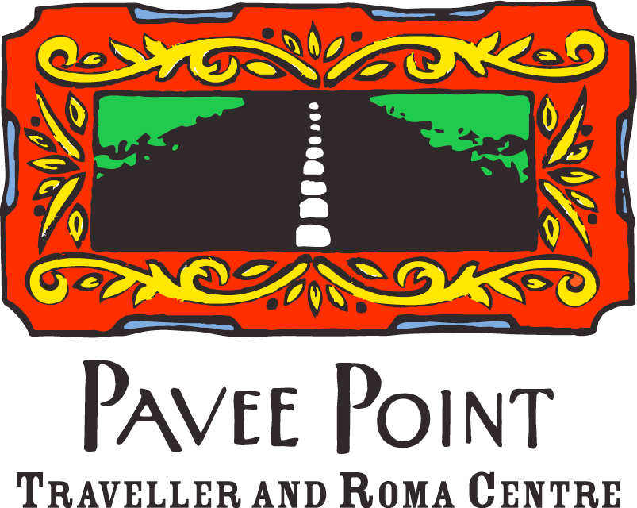

Pavee Point Opening Statement to the Joint Oireachtas Committee on the Future of Mental Health Care

14th February, 2018

Pavee Point Traveller and Roma Centre

Pavee Point Traveller and Roma Centre (‘Pavee Point’) have been working to challenge racism and promote Traveller and Roma inclusion in Ireland since 1985. The organisation works from a community development perspective and promotes the realisation of human rights and equality for Travellers and Roma in Ireland. The organisation is comprised of Travellers, Roma and members of the majority population, who work together in partnership to address the needs of Travellers and Roma as minority ethnic groups experiencing exclusion, marginalisation and racism. Working for social justice, solidarity and human rights, the central aim of Pavee Point is to contribute to improvement in the quality of life and living circumstances of Irish Travellers and Roma, this includes targeted resources and recruitment to ensure access to effective, equitable and respectful quality mental health care and services.

For further information contact:
Ronnie Fay, Co-Director Martin Collins, Co-director
ronnie.fay@pavee.ie martin.collins@pavee.ie
Tel: +353 1 878 0255 Tel: +353 1 878 0255

Introduction
Good afternoon, my name is Patrick Reilly, I am the mental health worker in Pavee Point. I am also an Irish Traveller. Myself and my colleague, Brigid Quirke are delighted to have the opportunity to make this presentation to the Committee. While we thank the Committee for including Travellers and Roma in your discussion today, we would like to note that we have been invisible thus far and urge the Committee to take our recommendations on board and ensure that we are explicitly included in the Committees final report.

We welcome Minister Harris’ commitment to re-establishing the Traveller Health Advisory Committee and the development of the new Traveller Health Action Plan based on the findings of the All Ireland Traveller Health Study. We urge the Committee to prioritise these actions and ring fence a budget for their implementation as a matter of urgency.

Given the limited time and the complexities of the issues we wish to highlight, we are going to focus explicitly on Travellers today. However, we would encourage the Committee to examine the mental health needs of the Roma community at a later stage in your deliberations. We have copies of the National Roma Needs Assessment for your consideration and our Roma colleagues would welcome further discussion on the mental health findings and key recommendations.

Irish Travellers
There are approximately 40,000 Travellers in Ireland, accounting for less than 1% of the total population. If you want to visualize that, if you put the entire population of Travellers in Croke Park, it would fill less than half the stadium. What we’re recommending today is practical, feasible and if implemented, could have a real impact on Travellers health.

Last year Traveller ethnicity was officially acknowledged by the State, Travellers across the country celebrated and welcomed this announcement. However, the key challenges on the ground remain, this includes:
- Discrimination
- Exclusion
- Poverty
- Poor quality of education
- Lack of employment opportunities
- Lack of accommodation, leading to overcrowding (this is 7 times higher than the settled population).

To add to this, we know that there are approximately 2,000 Travellers on the roadside without basic facilities. These are your constituents, the people that you represent.

In 2018, this is something that we expect in a developing country, not a rich, developed nation like our country. Traveller health inequalities are well documented, with the All Ireland Traveller Health Study findings indicating that Traveller health is comparable with the levels found in the settled population of the 1940’s. This means that:
- Life expectancy for Traveller men is 15.1 years and for Traveller women 11.5 years less than men/women in the settled population
- Traveller men have 4 times the mortality rate of the settled population and for Traveller women this is 3 times the mortality rate of the settled population
- Infant mortality is 4 times higher

The evidence tells us that Travellers are dying at much higher rates, at all ages and across genders, with 97% of Travellers not living to their 65th birthday. This, together with the experience of discrimination on a daily basis leads to poor mental health. We know that Travellers have the worst mental health outcomes than any other group in the country, this is why we have been prioritised on paper through policy documents (i.e. Connecting for Life, AVFC), but in reality, we, as Travellers, see very little change on the ground. Again, the All Ireland Traveller Health Study found:
- 60% of Travellers reported that their mental health was not good in the last 30 days compared to 20% of the settled population; and
- Traveller suicide is 6 times higher than the settled population, accounting for approximately 11% of all deaths

This would be totally unacceptable in any community, and rightly so. My community shouldn’t be any different. If we had access to the same resources and services as the settled population, the outcomes would be better. And I believe we can do better for Travellers.

In order to do this, we need to address the issues experienced by Travellers when engaging with the services. This includes acknowledging the reality of being treated with lack of respect and dignity, which over 40% of Travellers had a concern with. Also, over 50% of Travellers worried about experiencing unfair treatment and had concerns about the quality of care they received. 40% of Travellers actually experienced direct discrimination in accessing health services. This is not simply anecdotal; 70% of service providers agreed with these findings and suggested that Travellers received substandard services because of their ethnicity.

As noted in our submission, Traveller health hasn’t received any new monies since 2008. We welcome the launch of the National Traveller and Roma Inclusion Strategy (2017-2021) as the current policy on Travellers; Traveller organisations developed this Strategy in partnership with the Department of Justice and Equality and we have widely endorsed it. However, no recommendations can be implemented without a budget; and there is no budget attached to this Strategy. This adds to the ongoing frustration for Travellers on the ground as we see little progress.

What Travellers are seeing is other Travellers on the ground through the Traveller Primary Health Care Projects which are funded by the HSE. As the study suggests, 83% of Travellers receive their health information from these projects. They are a lifeline for my community. Again, they need to be resourced and seen as an investment by the State.

Going forward, what it is needed is active Traveller consultation, participation and proofing of any further development of services, policies and strategies. This must be resourced, monitored and evaluated.

The Committee has received our detailed submission which includes clear recommendations in relation to access, recruitment and funding. However, in the interest of time, we would like to highlight the following two overarching recommendations:

- Ensuring a Robust Evidence Informed Service: Ethnic Data
- Prioritise the implementation the ethnic identifier across all primary mental health services, to monitor equality of access, participation and outcomes to suicide prevention and mental health services for Travellers, Roma and other priority groups.

- Working in partnership with Travellers: ‘Nothing about us without us’
- Engage and work in partnership with Traveller organisations and Primary Health Care Traveller Projects (peer led culturally appropriate projects) to develop and deliver a positive mental health awareness and suicide prevention campaign. These structures have existed for at least 15 years with 30 projects operating nationally. There are 10 of these projects in the areas in which I work (CHOs 6, 7, and 9) and I was disappointed sitting in the gallery a few weeks ago listening to the Chief Officers who did not acknowledge Travellers and/or the work of these projects, which they fund and work with us in partnership.

Conclusion
To conclude, we urge the Committee to strongly recommend the implementation and resourcing of the National Traveller and Roma Inclusion Strategy without delay. Again, the re-establishment of Traveller Health Advisory Committee is crucial and this must be done as a matter of urgency. This is vital. Travellers are dying and we can’t understand the lack of progress on the ground. The question that must be addressed- is this political?

Finally, I would like to thank the Committee for the opportunity and for listening to our presentation. We welcome any questions and/or matters for clarification. We would also welcome Committee Members to visit Pavee Point and meet our Primary Health Care Project.

Appendix: Traveller Mental Health Key Facts and Figures
(Joint Oireachtas Committee on the Future of Mental Health Care)
Health | Education | Accommodation
- 97% of Travellers die before their 65th birthday  - 42% of Travellers under 15 years of age compared with 21% of the general population  - 63% of Travellers under 25 years of age compared with 35% of the general population  - Only 8 Travellers found over 85 years of age | - 13% of Travellers complete secondary education in comparison with 92% of the general population.  - 57.2% of Traveller males were educated to primary level at most, compared with just 13.6% of the general population  - Less than 1% of Travellers go on to third level education | - Nearly 40% Traveller households had more persons than rooms compared with less than 6% of non-Traveller households  - Traveller overcrowding 7 times the national rate  - 12.2% of all Travellers are living in ‘temporary accommodation’ (NB: Pavee Point understands this as an undercount and estimate that 5,500 or 18.6% of Travellers fulfill this criterion  - Approximately 2,000 Travellers on the roadside without basic facilities% of

AITHS Key Findings: Mental Health and Suicide
- 62.7% of Traveller women and 59.4% of Traveller men reported their mental health was not good for one or more days in the last 30 days, compared to 19.9% of the non-Travellers  - 56% of Travellers said that poor physical and mental health restricted their normal daily activities, compared to 24% of the non-Travellers | - Overall Traveller rate suicide is 6 times higher than settled population  - Suicide is 7 times higher for Traveller men and most common in young Traveller men aged 15-25  - Suicide accounts for approx. 11% of all Traveller deaths  - Suicide is 5 times higher for Traveller women

AITHS Key Findings: Discrimination
- 53% of Travellers “worried about experiencing unfair treatment” from health providers
- Over 40% of Travellers had a concern that they were not always treated with respect and dignity
- Over 50% of Travellers had concerns of the quality of care they received when they engaged with services
- 40% of Travellers experienced discrimination in accessing health services, compared to 17% of Black Americans and 14% of Latino Americans
- 66.7% of service providers who agreed that discrimination against Travellers occurs sometimes in their use of health services. Mental health service providers also admitted that anti-Traveller discrimination and racism were evident within the services, resulting in substandard treatment of Traveller service users.

AITHS Key Findings: Trust in Health Services
- Traveller organisations and Primary Health Care for Traveller Projects (PHCTPs) were the most recognised and used support services for Travellers, particularly for mental health
- 83% of Travellers reported receiving health information and advice from PHCTPs
- The level of complete trust by Travellers in health professionals was only 41% compared with a trust level of 82% by the general population in health professionals

Summary of Key Recommendations

It is clear from existing evidence that Travellers experience a higher burden of ill mental health and suicide than non-Travellers and frequently experience difficulties in obtaining access to mental health services. This submission therefore considers equity in the provision of mental health service delivery through both mainstream primary care and targeted supports through Traveller Primary Health Care Projects. This requires an acceptance that equity is based not just on equality of access but on equality of participation and outcome and that the particular needs of Travellers require an innovative approach to planning in terms of access, recruitment and funding.

Access
- Prioritise the implementation of an ethnic identifier across all primary mental health services for Travellers and Roma, to monitor equality of access, participation and outcomes to suicide prevention and mental health services for Travellers, Roma and other priority groups.
- Engage and work in partnership with Traveller organisations and PHCTPs to develop and deliver a positive mental health awareness and suicide prevention campaign.
- Develop culturally appropriate mental health education materials in partnership with PHCTPs targeting both service user and family members.
- Support and promote anti-racism training among frontline primary care staff.
- Prioritise the implementation of the recommendations in the National Roma Needs Assessment, in particular a review of legislative and policy restrictions that impact on the provision of medical cards for Roma with no income. (A working group that includes representatives from the Heath Services Executive (HSE) Social Inclusion Unit, Roma support groups, and the HSE Medical Card application processing unit needs to be established to develop a pathway for medical applications).
Recruitment
- The performance management system for staff in the public sector should include wider criteria in their measurement of performance to include outcomes in terms of progressing equality for Travellers and Roma in Ireland as per Section 42 of the Irish Human Rights and Equality Act, 2014 (‘positive duty.’)
- Given the importance of adopting principles of inter-culturalism and equality, we would urge the Department of Health and agencies within its remit to target the employment of Travellers and Roma in any future recruitment processes. This would enhance the capacity of the agency and include the expertise of these communities.
- Provide resources to encourage the extension of the PHCTPs to address mental health and suicide prevention. Resources would include the training and employment of dedicated Traveller mental health and youth workers in each area where there is a significant population of Travellers.
- As part of the recruitment process of staff, criteria for employment and job descriptions should include provisions for a commitment to anti-racist and equality perspective. Job descriptions of staff should also reflect this perspective in terms of essential skills. Ongoing anti-racism and discrimination training for all staff should be prioritised.
Funding
- The work of the Traveller Health Units (THUs) should continue to be resourced and their role and influence enhanced. Senior management at Community Healthcare Organisation level with responsibility for primary care, mental health and other key health services should be mandated to become part of the THU structures in all regions.
- Increased funding for the delivery of peer led Traveller-specific mental supports through Traveller Primary Health Care Projects with a view to the supporting the development of Traveller Mental Health Rapid Response Teams in local areas which would respond to crises as they arise and provide appropriate interventions in the event of attempted suicide and in providing supports to the family members in terms of bereavement following a suicide.

http://www.cso.ie/en/releasesandpublications/ep/p-cp8iter/p8iter/p8itseah/
https://www.housing.gov.ie/sites/default/files/publications/files/annual_count_of_traveller_families_in_2016_in_all_categories_of_accommodation.pdf
https://www.ucd.ie/t4cms/AITHS_SUMMARY.pdf
https://www.ucd.ie/t4cms/AITHS_SUMMARY.pdf
https://www.ucd.ie/t4cms/AITHS_SUMMARY.pdf
http://www.cso.ie/en/csolatestnews/pressreleases/2017pressreleases/pressstatementcensus2016resultsprofile8-irishtravellersethnicityandreligion/
http://www.cso.ie/en/csolatestnews/pressreleases/2017pressreleases/pressstatementcensus2016resultsprofile8-irishtravellersethnicityandreligion/
https://www.housing.gov.ie/sites/default/files/publications/files/annual_count_of_traveller_families_in_2016_in_all_categories_of_accommodation.pdf
Section 42 of the Irish Human Rights and Equality Commission Act 2014 mandates all public bodies to take proactive steps to assess and promote equality, protect human rights and eliminate discrimination, see here: http://www.irishstatutebook.ie/eli/2014/act/25/enacted/en/html

