# Pavee Point Supplementary Submission to the upcoming HEA Equity of Access Plan

This short paper builds, in the light of both current Traveller concerns and ongoing equality and rights discourse, on previous Pavee Point submissions and interventions in support of development and completion of the upcoming Higher Education (HE) Equity of Access Plan. In light of the data below we now believe that a minimum of 150–200 p.a. new Traveller entrants at the end of three years, 250–300 p.a. by the end of five years and 400–500 p.a. by the end of seven years is required. Participation and progress to postgraduate and higher studies also needs to be tracked as well as final employment and other outcomes.

The setting of Traveller targets with an associated Plan and support initiatives in the HE Equity of Access Plan dates created a significant focus throughout HE on Traveller access and participation. Up to the first COVID lockdown of 2020, when numbers again dropped, first year Traveller HE entrants increased year on year (2020 is the last year for which statistics are available). The targets, while important as indicated, were very modest and were viewed by some Travellers and Traveller organisations as further indication of the education system's perceptions and expectations of Travellers.

To support and reinforce Traveller education ambition, progress Traveller education rights and extend the HE focus on Traveller participation in all programmes at all levels, targets in line with and/ or relating to participating numbers or percentages from other cohorts need to be set. These then need to be supported by special measures and resources including employment initiatives, systemic implementation and inclusive monitoring.

This submission focusses on Travellers but the arguments and aims also apply to Roma.

# Statistical indicators of capacity to grow Traveller entry into HE

A small but growing number of Travellers are entering HE. This must be strongly supported, because Travellers who make this transition represent a major cultural shift for the community overall, and these pioneers are pointers for younger Traveller students as to what they can achieve.

Because the numbers entering HE are so small, across the years for which statistics have been collected in the HEA initiative to promote Traveller participation, any dip or variation stands out. COVID has had disproportionate negative impact.

For this profile, data on Traveller education are brought together from three sources: the 2016 Census, the Department of Children and Youth Affairs (DCYA) *Young Travellers* report (2020), and the Department of Education (its 2017 statistical report on Travellers in school covers school years 2009/2010–2015/2016, but the DES did provide some data for 2017-2019 to the DCYA, 2020).

*Note:* figures throughout are for Leaving Cert enrolments, and cannot be taken to infer completion. Data disaggregated by ethnicity, on retention and completion are not available.

### The Irish Times Feeder school tables 2021 show that, of Leaving Certificate students:

* 99.7% in fee-charging schools progressed to third-level
* 80% from non-fee-charging schools went to college
* 62% in DEIS schools went on to HE

These figures by school type indicate how the overall HE orientation of schools an influential factor, especially for students from communities with weak engagement with HE.

## Traveller enrolments in DEIS and non-DEIS post-primary schools in 2015/2016

|  |  |  |  |
| --- | --- | --- | --- |
| **Total post-primary programmes** | **DEIS** | **non-DEIS** | **Total** |
| Number of Travellers enrolled in DEIS/non-DEIS schools | 1,220 | 1,469 | 2,689 |
| % of enrolled Travellers in DEIS/non-DEIS schools | 45.0% | 55.0% | 100% |
| Travellers as % of total enrolment in DEIS/non-DEIS schools | 1.8% | 0.5% | 1.2% |

DES 2017, p.4 and Table 12.

The main published age-band and Senior Cycle Traveller enrolment data are from 2015-2016 (DES 2017); the DCYA (2020) also cites DES data for 2018/2019. Regarding improvement in Travellers’ HE-transition rates, the main available relevant data are enrolments in the established Leaving Certificate programme, and more particularly, in the second (exam) year of that two-year programme. Published enrolment data are only available for the 2-year programme as a unit, so to establish something close to the population of Travellers that might transfer from post-primary school to HE, those two-year enrolment numbers are halved in the profiling that follows here. This may favour the numbers in the exam year, but that makes up to some degree for the uncounted alternative-entry numbers of Travellers from FET and other mature student pathways.

The changes in enrolment profiles in Leaving Cert exam years since 2009 are as follows:

## Traveller Enrolments by Leaving Certificate programme and relevant age band, 2009–2018

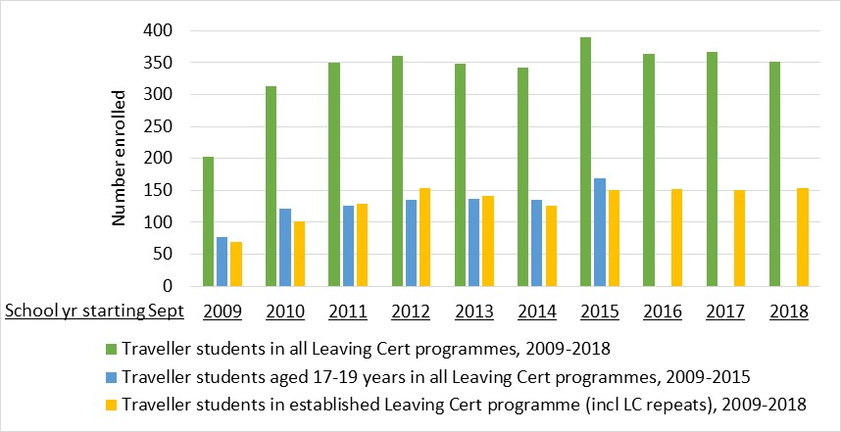

2009–2015 data: DES 2017, Tables 10 & 11; 2016–2018 data: DCYA (citing DES) 2020, Table 29.

In the seven years from 2009/10 to 2015/16, numbers of Travellers enrolled across the three Leaving Cert programmes almost doubled, growing from 405 to 780 students. Within that Cycle, numbers enrolled in the final year of the established Leaving Certificate programme grew from 70 to 151 Traveller students.

This growth stalled and fell back in the years after termination of Traveller support services during the recession. Transfer to post-primary Junior Cycle had become the norm; this declined, but has recovered. However, beyond enrolment a number of issues requiring support at both first and second levels remain outstanding and require interventions.

The most persistent decline in Senior Cycle numbers occurred in the Leaving Certificate Vocational Programme and LC Applied; enrolments in the established Leaving Cert fell in 2013 and 2014, and then returned and have stabilised at around 2012 levels.

Traveller organisations reported widespread concern regarding the possible impact of COVID and related school closures on this recovery. However, that concern itself is evidence of education ambition, and the enrolment numbers should continue to grow, given implementation of appropriate measures to counteract the impact of the lockdown.

As noted above, there are no available disaggregated data regarding Travellers’ retention and completion levels, but there is widespread concern about these. Year-on-year dropout rates can be identified from published data on enrolments by one-year age-bands, and these suggest that there could be a wide gap between Travellers’ Leaving Cert programme enrolment and completion levels to the required standard for entry into HE courses being considered.

In 2018/19, numbers as a percentage of the relevant target age-band populations were as follows:

## Travellers enrolled in Senior Cycle and in the established Leaving Certificate programme, 2018/2019

|  |  |  |
| --- | --- | --- |
| **Programme** | **Travellers enrolleda** | **% of age-band populationsb** |
| All Leaving Cert programmes | 704 (of which 352 in final year) | 29.1% of 16-19-year-olds (n=2423) |
| Est Leaving Cert (incl repeats) | 307 (of which 153 in final year) | 17.3% of 17-19-year-olds (n=1772) |

aDCYA 2020, Table 29; data supplied by the DES. bCSO, Census 2016, Table E8014

Retention levels in the Leaving Cert cycle are improving, especially in the older age bands. The 17-19yr-old Traveller student numbers held steady through the recession, and also showed marked resilience, 2014-2015. Data available from then to 2018 is not age-banded, but show that overall growth is continuing. This suggests growing ambition for education, and for continuing to higher levels.

## Enrolments by age band, Traveller students ages 16-19 years, by academic year

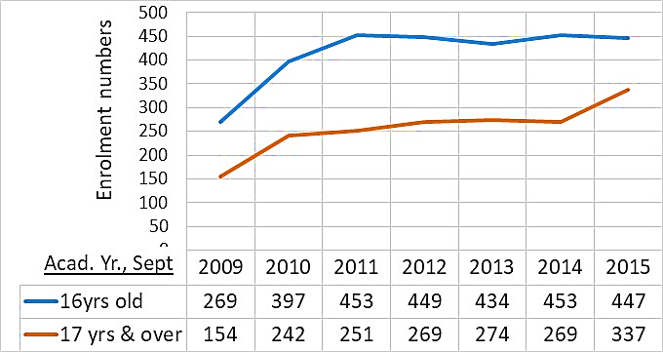

The graphs and tables in this submission indicate that progress in education is uneven, but over the years, it does happen. Crises such as the COVID pandemic and associated lockdowns have had marked impact, especially on marginalised groups such as the Travellers – so, the recent drop in numbers of HE first-time entry Traveller students, from 48 in 2019/2020 to 39 (HEA 2021), is not surprising. Provider expectations and ambition for the future should be fuelled by the long-term trends. The total number of Travellers students in HE “increased from 35 (2012/2013) to 61 (2017/2018); a 74% increase” (DES, 2021, p4).

Identifying specific target numbers for HE Entry over the coming seven years is difficult, given the limits of the available statistical data on which to base them. Targets must be grounded in the current reality, but must also be visionary -- push the boat out, challenge/inspire potential HE students to shake off the limits imposed by a history of exclusion and denigration, and to aim to fulfil their true potential.

# Target for the next three, five, and seven years

As noted above, the Irish Times (2022) reported the latest national HE transition rates, by school type:

* 80% of Leaving Cert in non-fee-charging schools (55% of enrolled Travellers are in these schools)
* 62% of Leaving Cert in DEIS schools (45% of enrolled Traveller s are in these schools).

In this table, the above percentage rates have been used to calculate possible target numbers for transition to HE (again, it must be remembered that the baseline figures are for Leaving Cert final-year enrolments, not completion; also, it is presumed that all would attain the Leaving Cert results required for HE entry):

## School-to-HE transition numbers required for Travellers to achieve parity with majority students in non-fee-paying schools or DEIS schools

|  |  |  |  |  |  |
| --- | --- | --- | --- | --- | --- |
| **Leaving Certificate  final-year enrolments** | **Of which --** | | **HE Transitions parity** | | **Total HE transitions** |
| **55% in  non-fee-paying schools** | **45% in DEIS schools** | **80% from non-fee-paying schools** | **62% from DEIS schools** |
| 153 (=2018 Enr) | 84 | 69 | 67 | 43 | 110 |
| 307 (=2018 Enr x2) | 169 | 138 | 135 | 86 | 221 |
| 459 (=2018 Enr x3) | 253 | 114 | 202 | 71 | 273 |

Numbers of Travellers enrolled in Senior Cycle doubled in the seven years from 2010 to 2015, and numbers in the established Leaving Cert programme trebled. A similar growth rate in Leaving Cert enrolments and completion numbers, should be the aim for the coming seven years. The three-year, five-year and seven-year targets suggested below will require supports to ensure that Traveller students enrolled in the Leaving Cert programme, complete it to the level required for HE entry.

## Target numbers for HE entrants from the Traveller community

Given the limits attending these data, these suggested targets are tentative. But to promote education ambition among severely marginalised communities, institutions must be ambitious for them.

|  |  |
| --- | --- |
| **Time frame and conditions** | **Target first-time entry number** |
| At the end of three years, assuming Travellers’ Leaving Cert enrolments continue steady, and course completion rates have risen to parity | 150–200 p.a. |
| At the end of five years, if Leaving Cert completion rates have doubled | 250–300 p.a. |
| At the end of seven years, if Leaving Cert completion rates have tripled | 400–500 p.a. |

# Key prerequisites to permit Travellers to achieve entry to HE

* Investment in measures to promote enrolment, retention, attainment and completion at post-primary level are essential to ensure this aim.
* Partnerships engaging HE colleges with Traveller organisations and communities, and post-primary schools and in identifying such measures and ensuring their implementation is essential.

# Data Sources

CSO, *Census 2016 Profile 8 - Irish Travellers, Ethnicity and Religion,* Table E8014. Available at <https://www.cso.ie/en/csolatestnews/presspages/2017/census2016profile8-irishtravellersethnicityandreligion/>

DCYA (2020).  *Young Travellers in Ireland. Spotlight#4.* <file:///C:/Users/User/Downloads/72732_824dc1d2acaf4e5a93d88e640ae1ef0f.pdf>

DES (2017). *Number of Pupils who are Members of the Traveller Community*. Statistical Reports, <https://www.gov.ie/en/collection/other-statistical-reports/>

DES (2019). *Action Plan for Increasing Traveller Participation in Higher Education* 2019-2021. <file:///C:/Users/User/Downloads/79100_1b57b3ea-7a1a-4106-a9e7-82d8eea21df4%20(1).pdf>

HEA (2019). *Action Plan for Increasing Traveller Participation in Higher Education 2019-2021.* <file:///C:/Users/User/Downloads/79100_1b57b3ea-7a1a-4106-a9e7-82d8eea21df4.pdf>

HEA (2021). Higher Education – Key Facts and Figures 2020/2021. Table 4 <https://hea.ie/2021/10/11/higher-education-key-facts-and-figures-2020-2021/#:~:text=Total%20Enrolments%207%2DYear%20Trend&text=Total%20enrolments%20increased%2017.4%25%20between,in%20total%20in%202020%2F21.&text=HEA's%20Head%20of%20Access%20Policy,availing%20of%20alternative%20entry%20routes>

Also <https://hea.ie/policy/access-policy/access-statistics-summary/>

*The Irish Times,* Friday, Jan 7, 2022. <https://www.irishtimes.com/news/education/students-in-fee-charging-schools-more-likely-to-progress-to-courses-with-high-points-1.4770522>