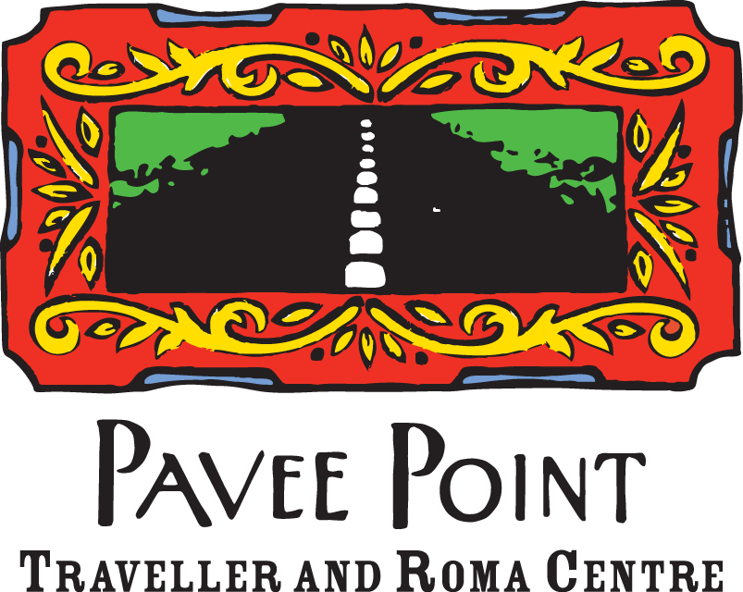

Submission to the Department of Further and Higher Education,Research, Innovation and Science on the Apprenticeship Action Plan 2021 to 2025

Date: September 2020

For further information contact:

Ronnie Fay, Co-Director Martin Collins, Co-Director

ronnie.fay@pavee.ie martin.collins@pavee.ie

Tel: +353 (1) 878 0255 Tel: +353 (1) 878 0255

**1. Introduction**

Pavee Point Traveller and Roma Centre is a national non-governmental organisation working to improve the quality of life, living circumstances, status and participation of Travellers and Roma.

We welcome the opportunity to contribute to the consultation on the Apprenticeship Action Plan 2021-2025, being undertaken by the Department of Further and Higher Education, Research, Innovation and Science. We note the request to structure responses in accordance with the headings in the Department’s consultation paper, in this regard, our submission will contribute to the section on “Increasing Participation” in apprenticeships.

**2. Recommendations**

Pavee Point make the following recommendations in regard to increasing participation in apprenticeships in Ireland. We further elaborate on these recommendations in section 4. of this submission:

1. Targeted, holistic, and integrated approaches to developing apprenticeship pathways for marginalised and disadvantaged groups are required.Such approaches should take cognisance of, and respond appropriately to the situation and experience of Travellers and Roma, and should ensure access and participation pathways adequately address the needs of disadvantaged and marginalised communities in the context of COVID-19.
2. The Apprenticeship Action Plan 2021-2025 should contain an explicit commitment to implement the public sector equality and human rights duty, and a Duty implementation plan should be developed setting out the actions to be taken under the life of the Action Plan.
3. The Census questions on ethnicity should be incorporated into the apprenticeship registration process. This should also record the ethnicityof Roma (which has been committed to in Census 2021).

**3. The situation and experience of Travellers and Roma**

The situation and experience of Travellers and Roma in regard to education and employment, is one of significant inequality of access, participation, and outcome, when compared to that of the majority population.

Census 2016 data indicate that the unemployment rate for Travellers, at 80 percent, is six times that of the general population.While educational disadvantage is a key factor in Traveller underemployment, there are other factor at play. A key barrier in this regard is the impact of racism and discrimination on Travellers pathway towards employment,[1]with Irish Travellers being ten times more likely than White Irish to experience discrimination when seeking employment.[2]

In regard to participation in, and outcomes from education, detailed analysis of Census 2011 data indicates that 91 percent of Travellers over the age of 25 had left school at age 16 or younger, compared to 25 percent of non-Travellers.[3]Census 2016 data indicate the following: 13 per cent of Traveller women are educated to upper secondary or above, compared with 69 percent of non-Travellers; 57 percent of Traveller men are educated to, at most, primary level, compared to 14 percent of non-Travellers; and very few Travellers are progressing to higher education(167 Irish Travellers held a third level qualification (an increase of just 78 from Census 2011).[4]

The Census does not currently capture disaggregated data regarding Roma, however, the National Roma Needs Assessment (2018) data indicate the following:

* almost 40 percent of Roma adults have never been to school (this was particularly marked for women with 41 percent of female respondents having never been to school compared to 22 percent of male respondents),
* for Roma learners, low levels of literacy in their mother language, combined with the challenge of learning English, present a compounding barrier for these learners to overcome if they are to actively participate in, and obtain good outcomes from further education and training.[5]

A further, significant, barrier for many Roma relates to the implementation of European Directive 2004/38 on the freedom of movement and residence and the Habitual Residence Condition (HRC). People from the Roma community who are unable to satisfy the HRC provisions are ineligible for state-funded supports and payments, including those linked to FET and job-seeking.

Despite significant and persistent levels of education and employment-related inequality, between the Traveller community and the majority population, national policy in these areas is silent on tackling such inequalities. The Department of Education and Skills Action Plan for Education 2016 to 2019, for example, contains one action in relation to Travellers: to, “increase the number of Travellers in Higher Education: 80 from a current figure 35 by 2019”[6]; and the Pathways to Work (Jobs) Strategy 2016 to 2020 does not name Travellers as a target group.

The 2018 Review of Pathways to Participation in Apprenticeship notes the particular barriers to apprenticeships experienced by people who are socio-economically disadvantaged. Such barriers include: lack of financial resources; homelessness; lack of access to transport; the impact of generational unemployment; attitudinal barriers; and lack of access to employment networks and contacts, which are crucial for those seeking apprenticeships.[7] All of these barriers exist for Travellers and Roma, and are compounded by additional barriers of racism, discrimination, and social exclusion.

Learning and training environments are rapidly evolving in the context of adapting to protect people from exposure to theCOVID-19 virus. The move to online learning, for example, has exposed and exacerbated issues which will create further distance for Travellers and Roma from education, training, and employment opportunities. Key issues in this regard are: digital literacy issues; lack of access to devices for online learning; lack of access to one-to-one learning and training supports; lack of space to participate in online learning due to living in overcrowded accommodation; and decrease in motivation due to the isolated nature of at-home learning. Research is emerging of the negative impact of online learning for disadvantaged communities, in particular.[8]These issues will need to be adequately addressed within the Department’s strategic approach to addressing underrepresentation of Travellers and Roma in apprenticeship programmes.

**4. Increasing Traveller and Roma Participation in Apprenticeships**

**4.1 Devising new forms of targeted, holistic, and integrated delivery**

Given the significant education and employment inequality gap between the Traveller and Roma communities and the majority population, together with the widening educational divide due to the move to online learning in the context of COVID-19 crisis, a significant orientation towards increase access to, and participation in apprenticeships for excluded minorities, is urgently required within the Apprenticeship Action Plan 2021-2025.

Pavee Point is concerned, however, that apprenticeship programmes are in fact becoming less accessible, in particular, for educationally and socio-economically disadvantaged groups. Concerns have been voiced, for example, that the increasing academic focus of apprenticeships and their greater alignment to higher education are presenting further barriers for potential apprentices, particularly those who are educationally disadvantaged.[9]When the latter issues are compounded with the afore-mentioned barriers which the COVID-19 crisis will continue to present, we believe that unless concerted efforts are made to provide holistic pathways towards apprenticeships, for Travellers and Roma, these communities will be further distanced from such employment options.

In this regard, we recommend that, within the mainstream apprenticeship programme, there is need for targeted, holistic, and integrated approaches that respond to, and take cognisance of the situation and experience of marginalised target groups, including Travellers and Roma. Such an approach would involve all of the following elements:

* activating key stakeholders (public, private, NGO) to collaboratively develop and drive targeted, holistic, and integrated approaches for those who are most distanced from pathways into apprenticeships: in particular, Travellers and Roma and their representative organisations should be active participants in this collaboration. The ‘eco-system’ model of integrated delivery for aCOVID-19 recovery public employment service, recently mooted by Murphy et al (2020), could usefully be drawn on as a modelin this regard;[10]
* adopting a co-production model of apprenticeship design and delivery, whereby target groups are active stakeholders rather than passive recipients. For Travellers and Roma, this would include actively involving these communities to develop culturally appropriate, inclusive apprenticeship pathways. The EU [10 Common Basic Principles on Roma Inclusion](https://publications.europa.eu/en/publication-detail/-/publication/7573706d-e7c4-4ece-ae59-2b361246a7b0)could usefully be drawn on in this regard;
* recognition of informal and non-formal learning as an entry into apprenticeships, in line with the EU Recommendation on a European Framework for Quality and Effective Apprenticeships;[11]
* provision of financial and other supports to encourage socio-economically disadvantaged people to access and remain in apprenticeships;
* delivery of pre-apprenticeship courses that are oriented to building skills and capacity to support progression into apprenticeships. Pre-apprenticeship courses should particularly target early school leavers and should aim to increase female participation;[12]and
* identification of key FET entry sites for delivery of targeted measures to progress Travellers into apprenticeships.

**4.2Compliance with the public sector equality and human rights duty**

Section 42 of the Irish Human Rights and Equality Commission Act 2014 requires public bodies, including government departments, to take proactive measures to prevent discrimination, promote equality, and protect human rights, for its service users, policy beneficiaries, and employees, and across all of its function areas. Statutory requirements under the Duty include: undertaking an assessment of the equality and human rights issues affecting identified groups (including Travellers and Roma); identifying and taking action on the key issues identified in the assessment that are relevant to the functions of the public body; and reporting on the assessment, the actions taken, and developments and progress to implement the Duty.[13]

In line with these statutory requirements, Pavee Point recommend that the Apprenticeship Action Plan 2021-2025 contain an explicit commitment to implement the public sector equality and human rights duty, and that a Duty implementation plan would be developed setting out the actions to be taken under the life of the Action Plan. In discharging on its statutory obligations under S42, the HEA, Solas, and the Department of Further and Higher Education, Research, Innovation and Science, should:

* consult with Travellers and Roma, and their representative organisations, and other relevant stakeholders, to identify factors that inhibit Travellers and Roma in accessing, participating, andprogressingin FET and training and to design culturally and gender specific responses; and
* provide anti-racist and intercultural awareness training for staff involved in the development and delivery of apprenticeship courses and for employers who offer apprenticeship placements.

The 2018 review of pathways to apprenticeships sets out areas of required action to promote greater diversity in apprenticeships, which would constitute a useful starting point in regard to discharging on the statutory requirements of the public sector duty. These areas for action include: encouraging employers to promote equal opportunities through, for example, qualifying criteria; promoting diversity through the Generation Apprenticeship Campaign; setting annual targets for diverse participation in apprenticeship(Pavee Point recommend that particular attention is required to develop targeted initiatives to encourage and support the participation of Traveller women and girls in apprenticeships and pre- apprenticeship courses, including in non-traditional areas); increasing practical supports for apprentices from under-represented groups, working with training providers, consortia, and employer representative groups; extending the bursary incentive to apprenticeships which have <20% female participation; undertaking an equality impact evaluation; and incorporating the Census questions on ethnicity into the apprenticeship registration process.[14]

**4.3Equality monitoring and the requirement for disaggregated data**

The lack of available disaggregated data, on the basis of ethnic origin, across FET provision and in regard to participation in apprenticeships, presents a significant obstacle to evidence-based planning and policy development at national level. This dearth of equality data also presents an obstacle to implementing and monitoring statutory requirements under the public sector equality and human rights duty.

At present national dataare not collected on the socio-economic or ethnic background of Irish apprentices. The researchers for the 2018 Review of Pathways to Participation in Apprenticeshipnotedthat they were not in a position to identify the number of Travellers engaging in apprenticeships, due to the lack of disaggregated data collection.[15]The Review, therefore, was unable to analyse the barriers and enablers across the apprenticeship pathway for Travellers and other minority ethnic groups. The Review recommended that the Census questions on ethnicity would be incorporated into the apprenticeship registration process. Pavee Point echo this recommendation with the suggestion that it immediately includes the Roma category until such time as the Census 2021 ethnicity question is in use.

1. Watson, D., et al (2017). A Social Portrait of Travellers in Ireland, Research Series No. 56, ESRI, 2017.
2. Mc Ginnity, F., et al (2017). Who experiences discrimination in Ireland?: evidence from the Equality module of the QNHS equality modules. The Economic and Social Research Institute and the Irish Human Rights and Equality Commission, Dublin.
3. Watson, D. Kenny, O. and McGinnity, F. (January 2017).[A Social Portrait of Travellers in Ireland. 71: Research Series Number 56, 15.](https://www.esri.ie/publications/a-social-portrait-of-travellers-in-ireland) The Economic and Social Research Institute, Dublin. Page 29.
4. Central Statistics Office, ‘[Profile 8 - Irish Travellers Ethnicity and Religion – Census 2016](https://www.cso.ie/en/releasesandpublications/ep/p-cp8iter/p8iter/) Results’ (Press Statement) (2017).
5. Pavee Point Traveller and Roma Centre and the Department of Justice and Equality (2018). [Roma in Ireland: A National Needs Assessment](https://www.paveepoint.ie/wp-content/uploads/2015/04/RNA-PDF.pdf).
6. Department of Education and Skills Action Plan for Education 2016 to 2019. Page 28.
7. Solas (November 2018). Review of Pathways to Participation in Apprenticeships. Page 6.
8. Carl O’Brien, July 20, 2020. Irish Times [“Return to distance learning in schools would widen digital divide experts warn”.](https://www.irishtimes.com/news/education/return-to-distance-learning-in-school-would-widen-digital-divide-experts-warn-1.4308209) Last accessed August 11.
9. Apprenticeships / Pre-Apprenticeships, and Community Education, Aontas 18/12/18
10. Murphy, M. P., Whelan, N., McGann. M., and Finn. P.(May 2020) The High Road back to Work: Developing an Irish Public Employment Eco-System for a COVID-19 Recovery Strategy. Maynooth University. MUSSI.
11. Council of the European Union. European Framework for Quality and Effective Apprenticeships. Brussels, 5 March, 2018. 6779/18.
12. The Pre-apprenticeship course delivered in the Dublin Institute of Technology in 2017 has been positively evaluated in demonstrating success in reaching participants experiencing barriers based on their socio-economic and ethnic status, and could, therefore, serve as a model in this regard.
13. The Irish Human Rights and Equality Commission (2019). [Implementing the Public Sector Equality and Human Rights Duty](https://www.ihrec.ie/app/uploads/2019/03/IHREC_Public_Sector_Duty_Final_Eng_WEB.pdf). Irish Human Rights and Equality Commission, 16-22 Green Street, Dublin 7.
14. Solas (2018). Op cit. Pages 13-14.
15. Solas (November 2018). Op cit.