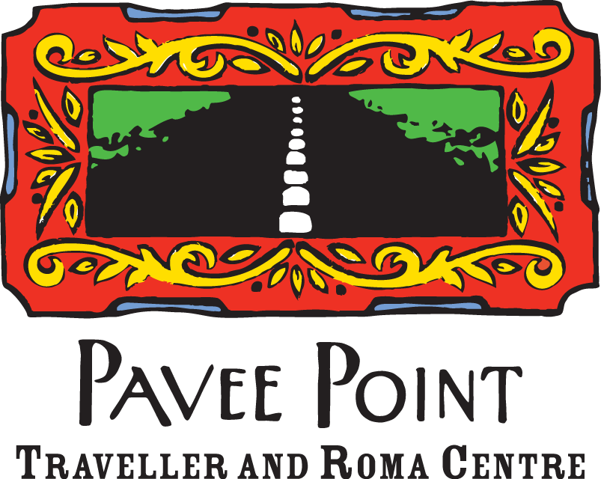

Job Description

Coordinator, Pavee Point Drug & Alcohol Programme

INTRODUCTION
The Drug & Alcohol Programme (DAP) was established in November 2000 and was known as the Traveller Specific Drugs Initiative until 2010. The central focus of this important and innovative programme is the promotion of Traveller inclusion in national, regional and local responses developed to address substance misuse, and to support Traveller organisations to tackle these issues within the community. The DAP has established a key role in the development of responses to drug issues in the Traveller community in Ireland, in partnership with a range of stakeholders at a local, regional and national level. This post is funded by the HSE.

The specific aims of the DAP in Pavee Point are to:
- Strengthen Traveller participation in responding to substance misuse issues
- Continue to develop and support a Traveller analysis and action of substance misuse issues
- Ensure Traveller inclusion in all relevant drug policy, research and service developments
- Develop, design and deliver a range of training modules and materials as appropriate for work with Traveller groups & service providers.

GENERAL DESCRIPTION OF THE POST
The coordinator will be responsible for developing and implementing the aims and objectives of the DAP and developing appropriate responses and strategies to address the issue of drug use in the Traveller community. The work plan includes:
  - Supporting the development of a collective community response to substance misuse within the Traveller community.
  - Engaging with mainstream services and statutory agencies to promote the development of culturally appropriate services.
  - Conducting training in good practice guidelines for D&A services and developing and delivering training for Traveller organisations based on their needs.
  - Undertaking research, policy submissions and developing pragmatic responses to emerging substance misuse issues in order to further the national understanding of Traveller related issues and support effective responses.
  - Engaging in policy making processes.
  - Supporting programme peer support workers and offering support to local organisations wishing to develop peer support worker roles.
  - Reporting, planning and management related tasks.

KEY TASKS
The key tasks of the Coordinator will include the following duties:
- Work with local Traveller organisations providing capacity building and technical support to develop responses to substance misuse issues;
- Facilitate the National Traveller Drug Network;
- Support Traveller workers and offer support to local organisations in developing Traveller support worker roles;
- Develop working partnerships with key agencies and organisations to deliver the work plan;
- Disseminate relevant information on D&A issues to Traveller organisations;
- Lead in the development of D&A education materials and training resources for the Traveller community that are culturally appropriate;
- Promote the programme to the wider substance misuse sector;
- Provide the sector with training and supports to ensure Traveller inclusion within their work;
- Develop submissions to promote the inclusion of Traveller specific issues into national and local policy;
- Contribute to the development of models of good practice in relation to Travellers and D&A use;
- Initiate work on emerging D&A issues which arise;
- Record and document the work of the project in order to meet the requirements of the organisation and funders;
- Participate in organisational and other meetings where applicable;
- Carry out supervision with other staff members/CE staff/trainees/students;
- Support Traveller engagement on D&A Task Forces at local and regional level;
- Represent the DAP and Pavee Point on external committees and at external events;
- Engage with the media where relevant;
- Undertake other duties as deemed relevant by the Director and/or line manager.

The ideal candidate will have:
- At least 3 years’ experience of community development work, drugs or drug related work with marginalised communities;
- Good working knowledge of the D&A sector at all levels from the ground to the National Drug Strategy and other relevant policies;
- A third level qualification or equivalent in a relevant area;
- Experience in the development and delivery of training within a community context;
- A proven capacity to initiate and develop work;
- Ability to lead and operate as part of a team;
- Excellent communication skills and interpersonal skills;
- Excellent report writing skills;
- Experience of staff and project management including administration and budget management, accessing funding and dealing with funders;
- A capacity to work with people from a wide range of backgrounds, agencies and sectors;
- A commitment to equality, cultural diversity and anti racism;
- Appropriate level of IT skills to carry out the position.

It is desirable that the person in this role has:
- Experience of formulating policy submissions and undertaking research;
- Ability to assess own work practices through the monitoring and evaluation processes of Pavee Point.

OTHER REQUIREMENTS
- Available to work flexible hours when necessary;
- Application of Pavee Point internal policies;
- Work as a team member of the DAP and Pavee Point as a whole to forward the organisational goals and objectives;
- Undertake duties as required by the Pavee Point Board and Director.

REPORTING RELATIONSHIP
The Coordinator will report directly to the Health Manager.

TERMS AND CONDITIONS
The appointment will initially be for one-year full time, renewable thereafter depending on funding. The salary will based on the Pavee Point Coordinator salary scale and the point on salary scale will be commensurate with experience. We offer a pension scheme and generous leave entitlements.
To apply, please email the attached job application to lee.davis@pavee.ie

Closing date for applications is 3rd January 2025. Interviews will be held the week of the 13th January, 2025.

Applications from Travellers, Roma and other minority groups are welcomed.

