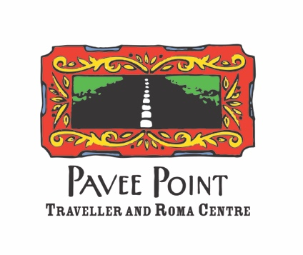

Roma Programme Co-Ordinator

Job Description

Title of position: Roma Programme Co-Ordinator
Reporting to: Co-Director
Location: Pavee Point Traveller & Roma Centre, 46 Charles Street Great, D. 1

Key Areas of Responsibility

Policy and Advocacy:
- Coordinate the work for policy and legislative change to progress Roma human rights;
- Lead strategic advocacy for the organisation with a focus on the implementation of Ireland’s National Traveller Roma Inclusion Strategy and the Roma National Needs Assessment;
- Lead a lobbying campaign for implementation of the Roma National Needs Assessment;
- Support Roma to mobilise their community in Ireland to influence policy;
- Identify patterns in treatment and experiences of Roma arising in Pavee Points work and develop relevant human rights submissions, policy positions and advocacy materials on Roma and Traveller rights;
- Convene a National Roma Network – a network of organisations working with Roma to ensure strategic collaboration and collective work to progress Roma human rights;
- Represent Pavee Point at national, European and international forums.

Training/Representation:
- Support and facilitate leadership and collective action within the Roma community;
- Ensure the organisation of strategic events to publicise and profile the work of Roma in Ireland.

Management:
- Manage the Roma programme in a strategic manner, based on the principles of human rights and community development;
- Lead strategic and organisational planning processes within the Roma team in line with Pavee Points strategic goals, objectives and organisational priorities.
- Lead the ongoing development of an advocacy strategy within the Roma team;
- Supervise and support the staff of the Roma team;
- Participate in Pavee Point internal structures as required.

Sustainability:
- Source and manage programme funding to ensure sustainability of the project;
- Regular reporting on the work of the project to management and funders;
- Development of and regular reporting into a monitoring and evaluation framework;
- Clearly articulate the work of Pavee Point and key messages in public forums;
- Ensure the development of resources and materials to profile the work of the Roma programme;
- Assist with wider work of Pavee Point Traveller and Roma Centre in order to meet the strategic goals of the organisation.
- Application of Pavee Point internal policies;
- Available to work flexible hours when necessary;
- Undertake duties as required by the Pavee Point Management Committee and Co-Directors.

Required Qualifications/Experience

- University degree in social sciences, community development, human rights or other related disciplines.
- At least 3 years’ experience, with progressively greater responsibility, in community development or human rights work.
- Experience in coordinating an advocacy, human rights and/or community project.

Skills & Knowledge

- Coordination and management skills;
- Strong leadership skills;
- Strategic advocacy and campaigning;
- Demonstrated skills in policy analysis;
- Skills in advocating to challenge racism and promoting equality and human rights;
- Strong understanding of community development and the human rights framework;
- Excellent analytical and writing skills;
- Excellent communication and interpersonal skills, including sensitivity and appreciation of intercultural and anti-racist approaches in a culturally diverse environment;
- Ability to work on own initiative and manage competing priorities;
- Show creativity in solving problems;
- Financial management and budgeting proficiency.

Terms & Conditions

Contract/Salary Scale: This is a full-time position, with some flexibility depending on the right candidate. Salary will be negotiable in line with experience, but will be in the range of €44,452-€60,789. We offer a pension scheme and generous leave entitlements. The length of the contract is subject to funding, and a probation period will apply.

How to Apply

Please fill in the Pavee Point Traveller and Roma Centre job application form
https://www.paveepoint.ie/wp-content/uploads/2025/01/Pavee-Point-Job-Application-Form.docx

Completed applications should be emailed to: oonagh.fay@pavee.ie by 5pm, Thursday 19th March 2026. Provision interviews will be held the following week.

Pavee Point is an equal opportunities employer

