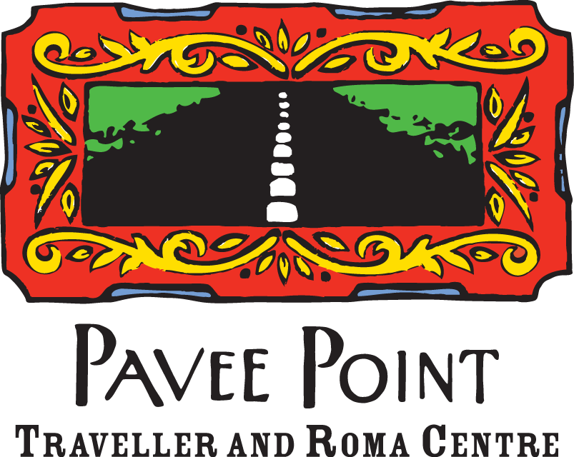

Vacancy - Policy and Research Officer

Pavee Point is a national non-governmental organisation working to promote the human rights of Irish Travellers and Roma. We adopt a community development approach to addressing the structural inequalities faced by Travellers and Roma. We work at local, national and international levels to influence policy and practice in areas including health, education, violence against women, arts and culture, drugs and alcohol, accommodation, employment, and anti-racism.

Our organisation adopts a partnership approach and employs staff from Traveller and Roma communities and members of the majority population. We are an equal opportunities employer and welcome applications from people of all backgrounds to bring diverse skills and perspectives to our work.

Role Summary
Pavee Point is seeking a Policy and Research Officer to support the organisation’s work to advance the human rights and social inclusion of Travellers and Roma. This is a new role and an exciting opportunity for a candidate with a strong interest in equality, human rights and social justice.

The Policy and Research Officer will work closely with management and programme teams to lead and support Pavee Point’s policy, research and advocacy work. The role will involve contributing to policy development and advocacy at national and international levels and supporting the work of Pavee Point’s research activities to strengthen evidence base and support the development of policy and advocacy strategies.

Job Title: Policy and Research Officer

Reports to: Assistant Director

Place of Work: Pavee Point Traveller and Roma Centre (46 Charles St. Great, Dublin 1). This position is office based with hybrid terms only available post probation period and then up to a maximum of 20% per week. Applicants are expected to live in Ireland or be willing to move to Ireland to take up the post.

Contract/Salary Scale: This position is for 35 hours per week, at a salary of €40,760 – €48,414 per annum, dependent on experience. The contract is a specified purpose contract for a period of 12 months initially renewable depending on, and in line with financial allocations and Pavee Point’s overall direction and development.

Eligibility: Candidates must hold a valid visa or work permit to work in Ireland.

Employee Benefits
- Generous annual leave, over and above the statutory minimum, contribution to pension plan, access to free car parking.

Key Duties and Responsibilities
Policy and Research:
- Undertake policy and research analysis on issues affecting Travellers and Roma to inform Pavee Point’s advocacy and programme work
- Monitor relevant policy developments at national, EU and international levels
- Provide policy advice, briefings and written contributions to support engagement with government departments and national and international agencies
- Draft policy papers, submissions, briefing notes and background materials to a high standard
- Contribute to building and strengthening the evidence base to inform Pavee Point’s strategic priorities and programme work
- Lead and support Pavee Point’s Research Advisory Group, ensuring research projects are relevant, rigorous and impactful

Advocacy and Organisational Work:
- Contribute to the development of Pavee Point’s policy positions across relevant programme areas
- Support Pavee Point’s engagement with national and international human rights monitoring and reporting processes
- Represent Pavee Point at meetings, consultations and relevant regional, national or international forums where appropriate
- Support the dissemination of research and policy outputs through reports, presentations, briefings and stakeholder engagement
- Contribute to advocacy initiatives aimed at promoting the rights and inclusion of Travellers and Roma
- Undertake other duties as required by management

Person Specification
Essential Criteria:
- Third level qualification in a relevant discipline (e.g. social policy, public policy, community development, human rights, research, or a related field) and/or relevant practical experience
- Demonstrated experience in policy analysis, policy development or research
- Experience producing high-quality policy documents, briefings, reports or written submissions
- Strong analytical, writing and communication skills
- Understanding of issues affecting Travellers, Roma and other marginalised or socially excluded groups
- Ability to work independently and collaboratively as part of a team

Desirable criteria:
- Experience applying community development principles in practice
- Knowledge of relevant policies and institutional structures relating to Travellers, Roma and social inclusion
- Experience developing policy positions or advocacy initiatives
- Experience working with a range of stakeholders, agencies and sectors in a collaborative or partnership context
- Ability to manage and organise work effectively, including leading specific pieces of work or projects
- Knowledge or experience of EU or international policy frameworks or human rights mechanisms relevant to minority ethnic groups, Travellers and Roma

Note: If you do not meet every criterion listed but believe you have relevant skills and experience, we encourage you to apply.

How to Apply:
On our application form with a short covering letter outlining your suitability for the role to hr@pavee.ie

https://www.paveepoint.ie/wp-content/uploads/2025/01/Pavee-Point-Job-Application-Form.docx

Closing date for applications: 28th May 2026

Shortlisted candidates will be invited for interview.

Equality Statement
Pavee Point Traveller and Roma Centre is committed to equality, diversity and inclusion and is an equal opportunities employer. Applications are particularly encouraged from members of Traveller and Roma communities and from other groups experiencing inequality. Reasonable accommodation will be provided to applicants with disabilities to support their participation in the recruitment process where required.

